
East West University

Lab Report
Semester: Summer-2025
Course Title: Electronic Circuits Course Code: CSE251
Section: 04

Expt No: 04
Expt Name: Introduction to Transistor
Group No: 06
Group Members:
Student Name | Student Id
Md. Hasib Ali | 2023-3-60-186
Arijit Kumar Anoy | 2023-3-60-055
Md. Shakib Al Hasan | 2024-1-60-200
Fahim Shahriar | 2023-2-60-094
Morshedul Islam | 2023-2-60-125

Submitted by-
Name: Md. Shakib Al Hasan
Id: 2024-1-60-200

Submitted to-
Dr. Sarwar Jahan
Associate Professor
Department of Computer Science & Engineering
East West University

Date of Performance: July 28, 2025
Date of Submission: August 09, 2025
Title: Introduction to Transistor

Objectives:
1. Identify base, emitter and collector terminals and connections of NPN and PNP transistors.
2. Demonstrate and measure the effects on base current of forward and reverse bias in the emitter-base circuit.

Theory (Summary):
It is convenient to represent the current voltage characteristics of transistor graphically. In a BJT common-emitter (CE) configuration, the emitter serves as the common terminal between input and output. The input is applied at the base terminal and the output is taken from the collector terminal. The typical CE output describes $i_{c}$ as a function of $V_{CE}$ with is as a parameter. In the active mode, $i_{c}$ of practical BJTs shows some dependence on $V_{CE}$ due to early effect. As a result, ic characteristics are not horizontal straight lines. This dependency of icon $V_{CE}$ is included in the equivalent circuit via an output resistance ro.

Equipment and Component:
1. Power supply
2. Multimeter
3. Resistor (95.16ΚΩ and 1.8ΚΩ)
4. Transistor (NPN and PNP)
5. Voltmeter
6. DC milli-ammeter and DC micro-ammeter

Circuit Diagram:

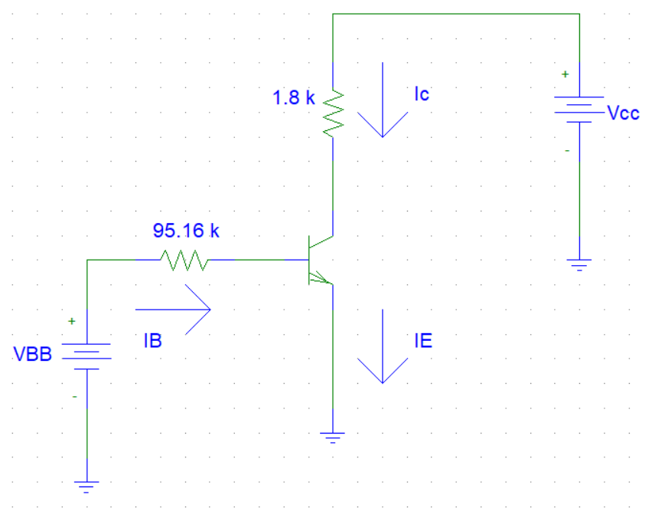

Figure-1: Circuit diagram for measuring I-V characteristics of Transistor

Experimental Datasheet:
$$V_{BB}$$ | $$V_{CC}$$ | $$V_{B}$$ | $$V_{C}$$ | $$V_{CE}$$
10.119V | 1 | 9.510 | 0.9436 | 0.0085
 | 2 | 9.502 | 1.8962 | 0.0146
 | 3 | 9.495 | 2.912 | 0.201
 | 4 | 9.491 | 3.959 | 0.0251
 | 5 | 9.489 | 4.975 | 0.0296
 | 6 | 9.487 | 5.929 | 0.0335
 | 7 | 9.484 | 6.964 | 0.0374
 | 8 | 9.483 | 8.007 | 0.0411
 | 9 | 9.481 | 8.959 | 0.0442
 | 10 | 9.480 | 9.988 | 0.0476

$$V_{CC}$$ | $$V_{BB}$$ | $$V_{B}$$ | $$V_{C}$$ | $$V_{CE}$$
10.011V | 1 | 0.3489 | 1.5382 | 8.476
 | 2 | 1.3058 | 5.847 | 4.145
 | 3 | 2.985 | 9.844 | 0.2058
 | 4 | 3.302 | 9.938 | 0.0994
 | 5 | 4.341 | 9.973 | 0.0802
 | 6 | 5.317 | 9.966 | 0.0698
 | 7 | 6.312 | 9.972 | 0.0624
 | 8 | 7.301 | 9.982 | 0.0569
 | 9 | 8.412 | 9.984 | 0.0519
 | 10 | 9.393 | 10.00 | 0.0483

Post-Lab:
Plot $I_{c}-V_{CE}$ characteristics curve from the measured data using PSPICE and MATLAB
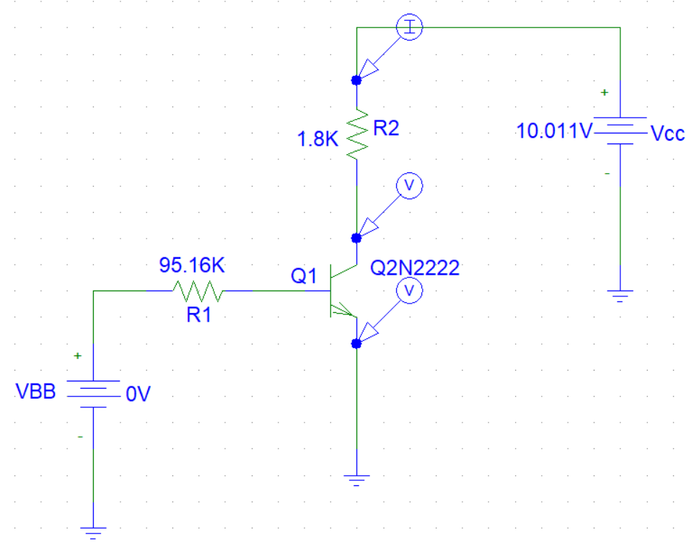
Answer

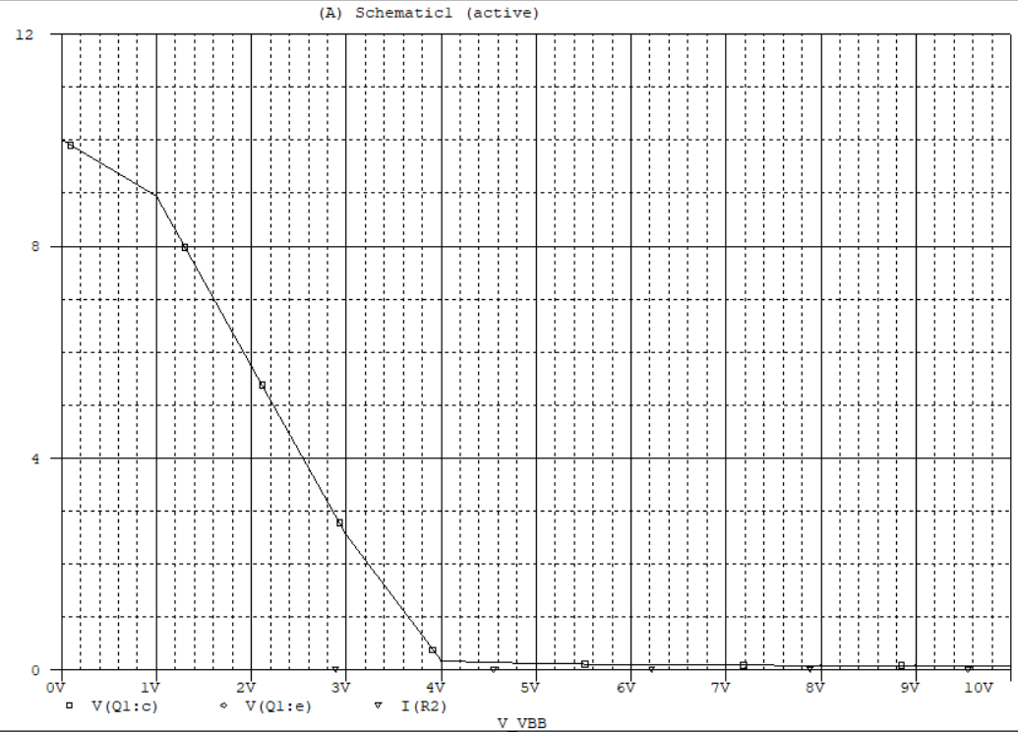

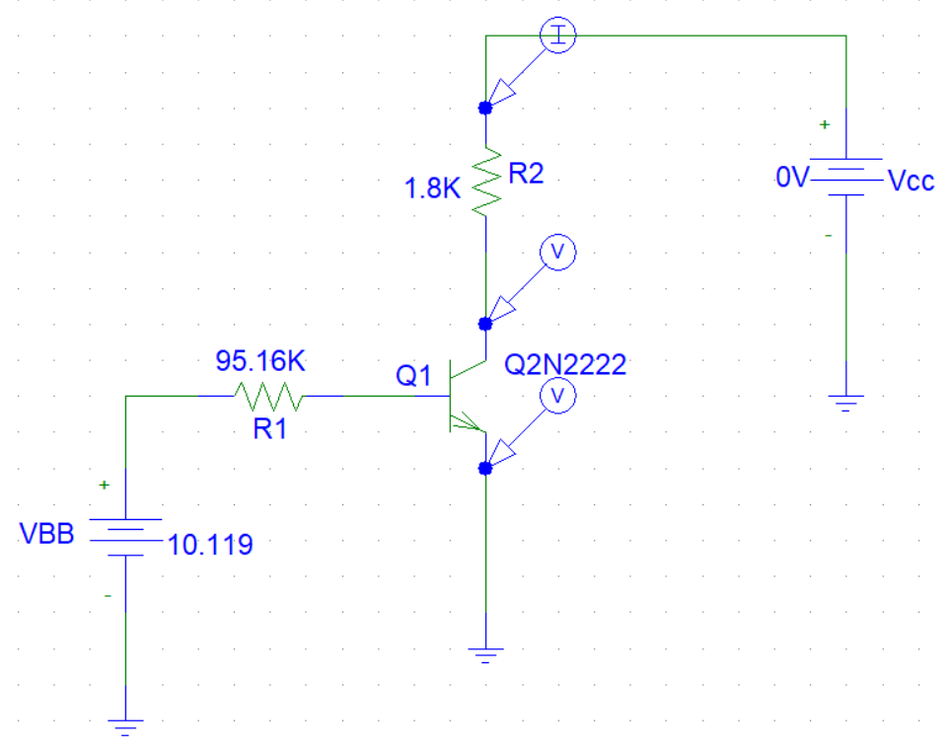

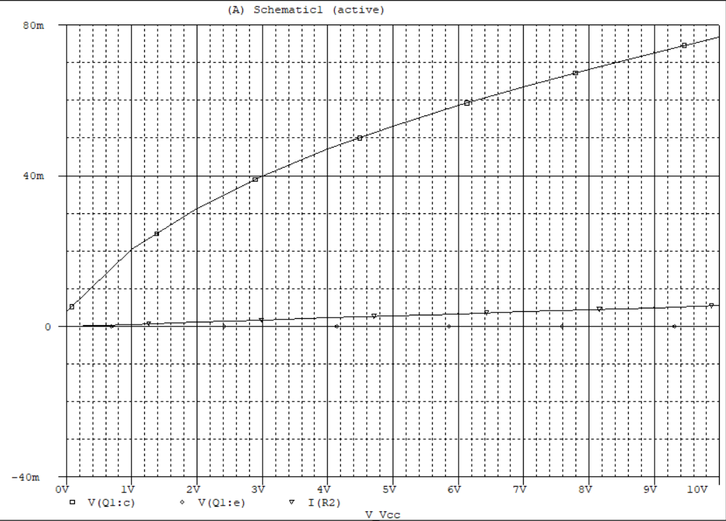

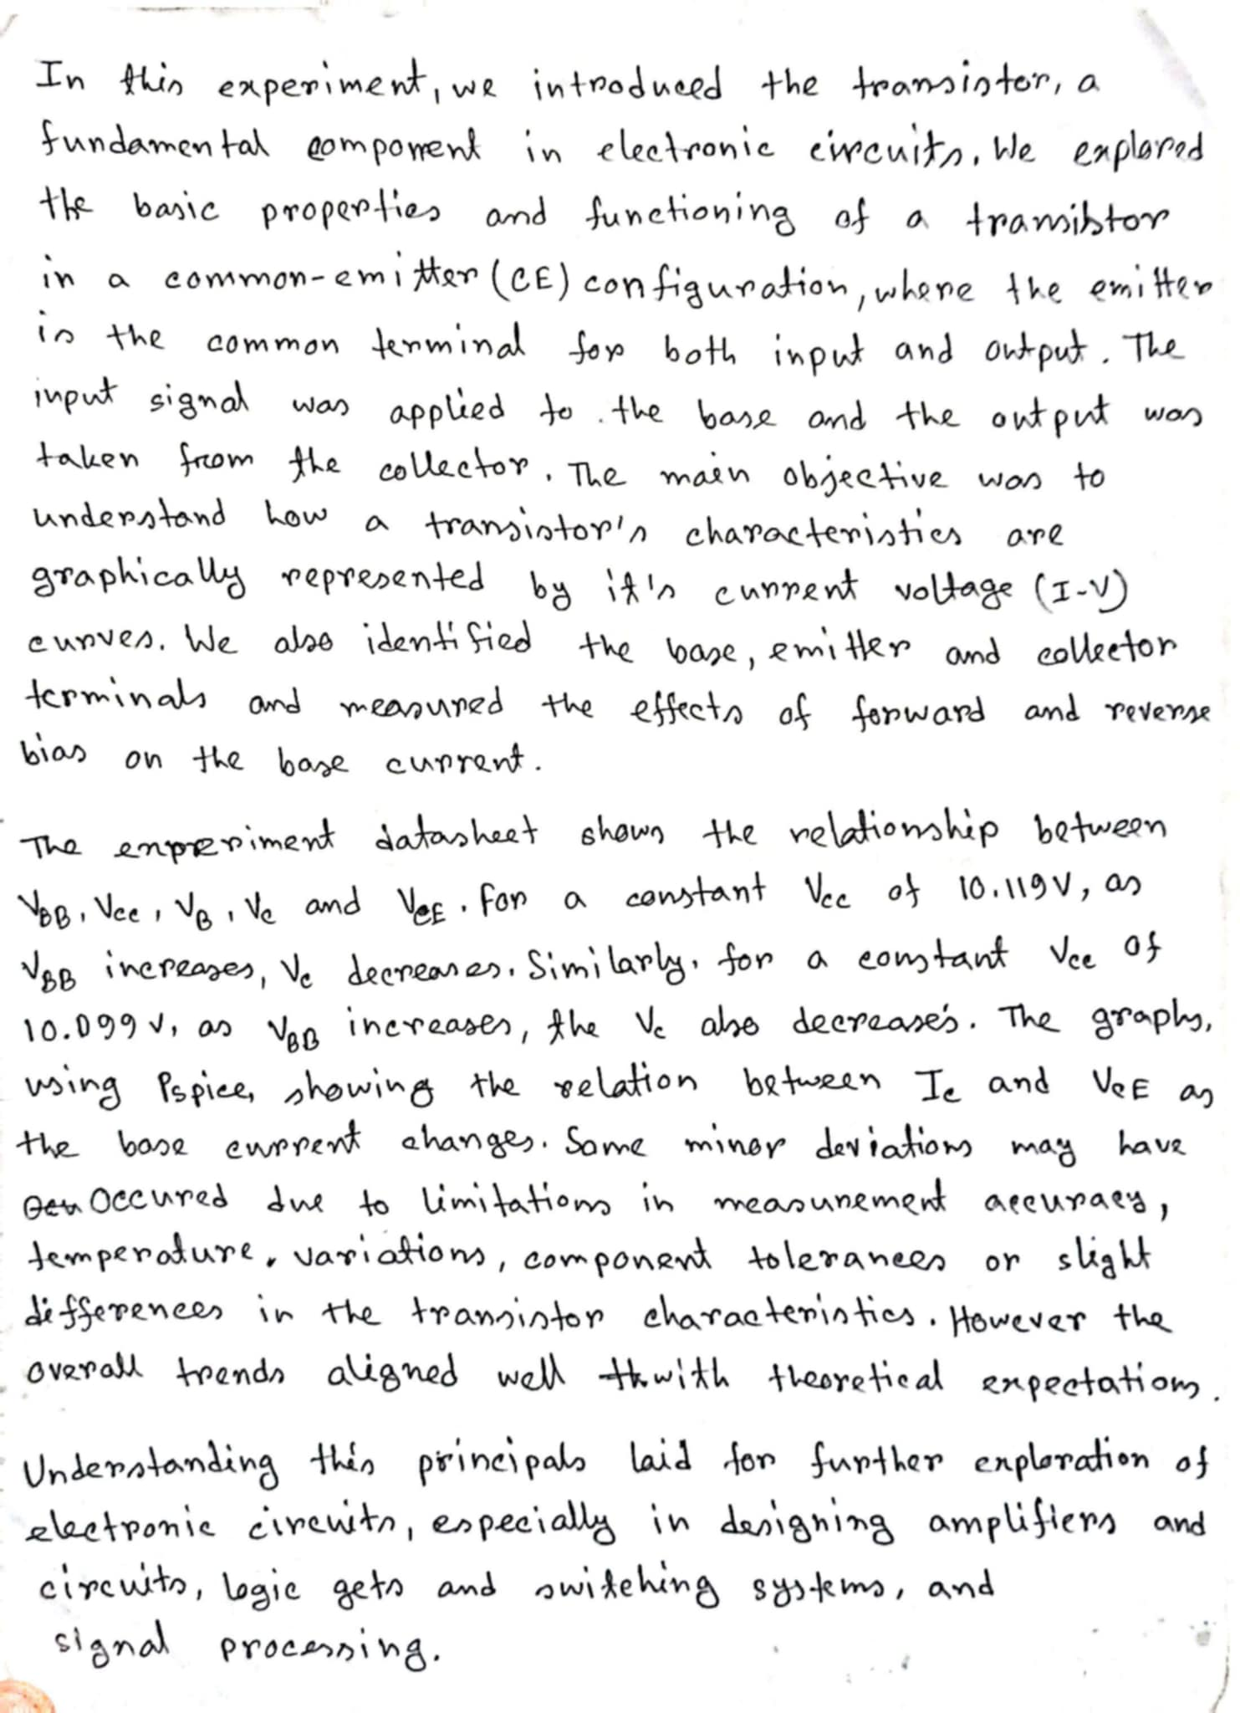
Discussion

